Digitizing Tempe High School Attendance Zones

Overview
This unit covers creating and editing vector data and attribute tables. In this lab module you will georeference JPG maps of high school attendance zone boundaries (AZBs) in Tempe, AZ and digitize the boundaries. In Tempe, and many other parts of the country, students are assigned to schools based on residence in an AZB. Unfortunately, there is no national database of these boundaries and often the information is maintained by individual school districts. The Longitudinal School Attendance Boundary Study (LSABS) has collected raw boundary data from hundreds of school districts across the country and is currently working to digitize these data. In this lab you will be contributing to LSABS efforts to create and publish a longitudinal database of AZBs to aid researchers, practitioners, and advocates for educational equity. Key techniques from this lab include rubbersheeting images of maps, creating new features, and editing existing ones.

Getting Started
Task: Load data
- Open a new ArcGIS Pro project and add the Tempe_HS2010 shapefile to your map.
- Right-click on your map in the Contents panel to access the Map Properties dialog box and click the Coordinate Systems tab. Make sure your coordinate system listed under Current XY is “NAD 1983 (2011) StatePlane Arizona Central FIPS 0202 (Meters).” If not, change to this projection by searching under Projected Coordinate System -> State Plane -> NAD 1983 (2011) (Meters).
- Increase the transparency of the Tempe_HS2010 layer by selecting the layer, navigating to the Appearance tab and increasing the transparency to around 30%.
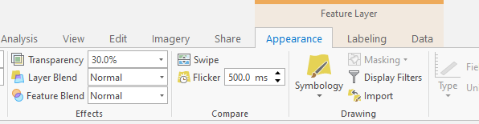

Georeferencing the 2019-20 High School AZB Map
Task: Add HighSchool_2019_20.jpg
- You will notice that once you add this image to your map it will show up in your Contents panel but not necessarily in your map extent. Additionally, the following warning will have appeared in the right-hand corner of your screen:
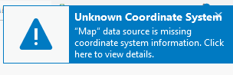
- This warning is appearing because we added a raster layer that has no spatial reference information and so ArcGIS doesn’t know where to plot the data. If you right-click on the HighSchool_2019_20 layer in the Contents panel and select Zoom To Layer, you will notice that the boundary map is being plotted somewhere completely nonsensical like the middle of an ocean. Georeferencing is the process of providing spatial reference information to raster data so that it can be viewed and analyzed like other geospatial data.
Task: Fit HighSchool_2019_20 to extent of Temp_HS2010
- Right-click on Tempe_HS2010 and select Zoom To Layer.
- Select HighSchool_2019_20 and then go to the Imagery tab and click Georeference to turn on georeferencing. Then, click Fit to Display to fit the high school JPG to the current map extent.
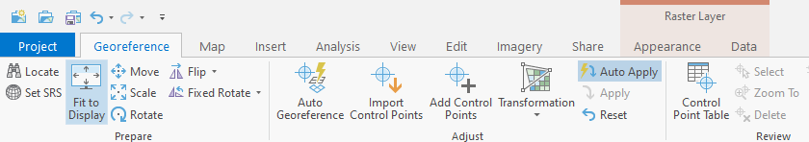
- Increase the transparency of the high school raster to roughly 50% under the Appearance tab and, if necessary, rearrange the layers so that it is on top.
Task: Align the HighSchool_2019_20 raster with control points
- In order to provide spatial reference to the raster, we need to match points on the raster with points on the underlying topographic basemap which has geographic coordinates. Street intersections make good control points as they are often labeled and not as likely to change. Avoid using water bodies as your control points, particularly when digitizing historical maps, as they can change frequently.
- Our first control point will be at the intersection of McClintock and Rio Salado Pkwy in the right-hand corner of the map. Click Add Control Points and click first on the intersection in the HighSchool_2019_20 map and then on the intersection where it appears on the basemap. You might find it helpful to toggle off the Tempe_HS2010 layer.
- HINT: If you run up against the edge of the map view and you are not finished placing the second point, you can click the mouse wheel and drag to pan without exiting the tool. If you are using a trackpad, hold C instead of the mouse wheel to pan. This same method can be used to pan when sketching polygons in the digitization process in the next section.
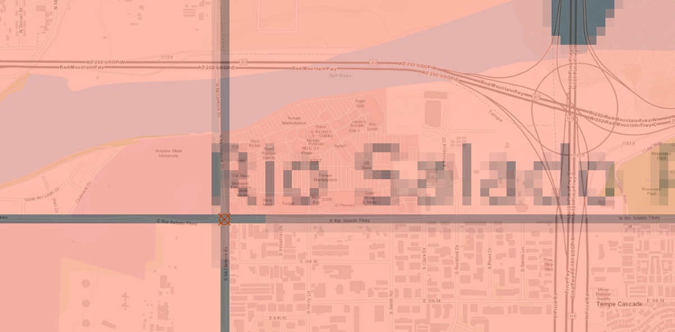
- You will notice that the map adjusted to align with the point you just placed. Our second point will be at the intersection of McClintock and Chandler. It is helpful to start georeferencing by placing control points close to the corners of the image.
- Place your third control point at the intersection of 32nd St and Liberty Lane. You will begin to see some warping of the raster image. This is to be expected as the map we are georeferencing was not drawn to scale. Continue to place points until you have ten control points. Try and distribute your points as evenly as possible at street intersections across the map. If you incorrectly place a point you can edit it by selecting it and dragging to move or you can delete it.
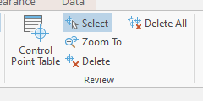
- After adding ten control points, you might notice that some of the points look something like this:
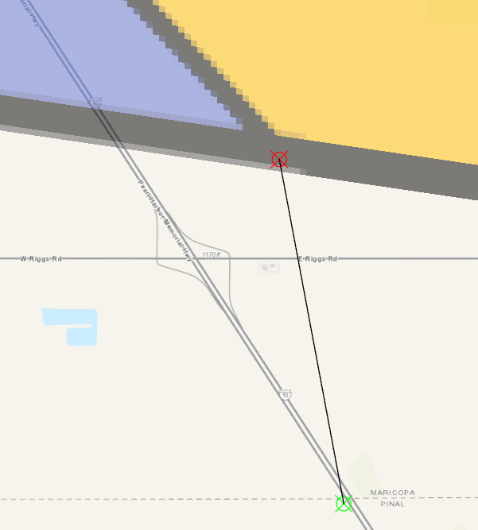
- These lines are occurring because of the default affine transformation ArcGIS Pro uses. Transformations are used to transform the points you’ve been selecting from the raster map to the map coordinates you’ve matched them to on the basemap. Different transformations have different properties, but we will be using the Spline transformation which ensures local accuracy at each point. This spline transformation is what is known as a rubbersheeting method as it is akin to placing pins and stretching a sheet of rubber.
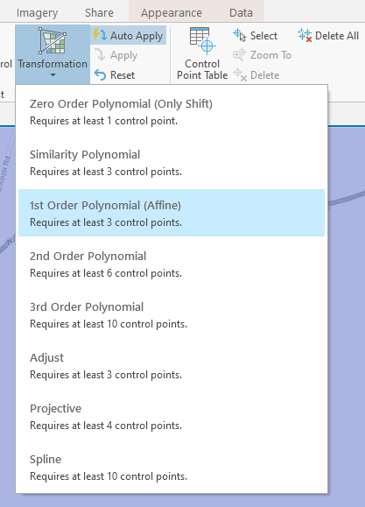
- Select the Spline transformation and click apply. You will notice that the points you placed are now correct, but there is significantly more warping in areas farther away from points. The more control points you place (and the more evenly you distribute them) the more accurate your georeferenced map will be. It won’t be perfect because it was not drawn to scale, but continue to place control points until it looks something like this:
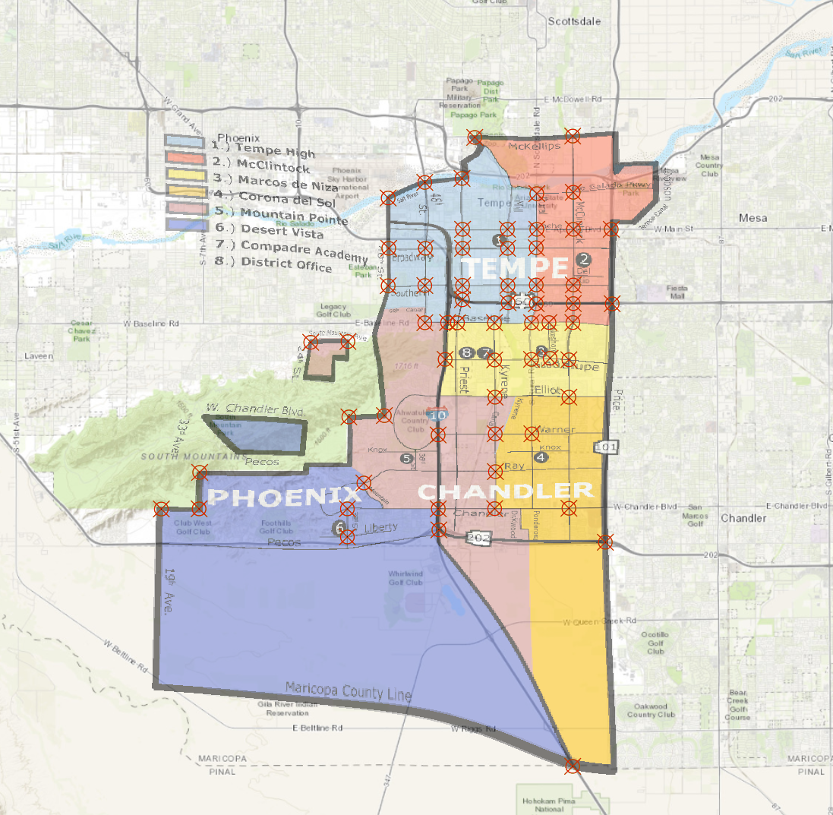
- Save your georeferenced raster and export your control points so that you can read them back in later if you made any mistakes. Exit georeferencing.

Introducing Digitizing
Task: Turn on Snapping Properties
- Click on the Edit tab and click to turn on Snapping.
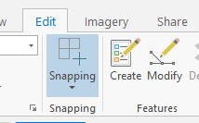
Task: Create a new shapefile
- We will start digitizing by creating a points shapefile of the high school locations. We are creating a shapefile rather than a feature class because, while they are both ESRI’s proprietary software, shapefiles have better interoperability with open-source GIS software. Within Arc Toolbox, go to Data Management Tools -> Feature Class -> Create Feature Class.
- Under Feature Class Location it will automatically fill the project geodatabase. Instead, change this to be a folder on your computer. This will save your new layer as a shapefile rather than feature class. Call your layer Tempe_SchoolsHS, make sure Geometry Type is set to Point and that the coordinate system is the NAD83 Arizona Central projection we selected for the project earlier. Click run in the bottom right corner.
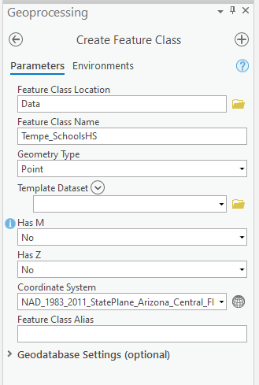

Task: Create new point features
- While selecting Tempe_SchoolsHS in the Contents panel, click on the Edit tab and next to snapping options click Create. In the right-hand Create Features sidebar, select Tempe_SchoolsHS and then select the Create Point icon.
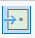

- Place a point at the location of Tempe High School. It is marked in the boundary map you georeferenced, but due to warping it may be somewhat offset from its actual location. Refer to the underlying basemap to make sure you are placing it in the correct location.
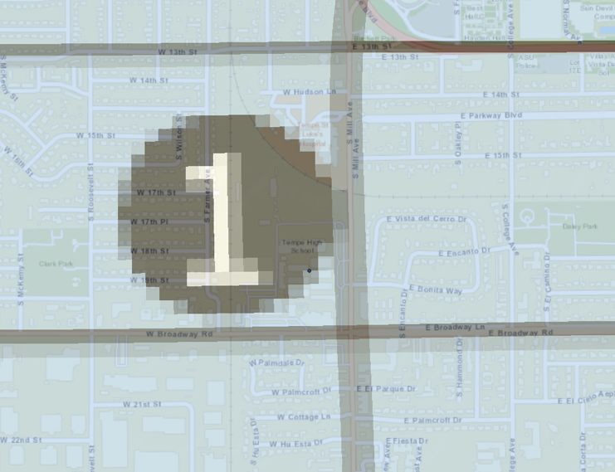

- Make sure to save your edits early and often!
- After saving your edits from your first point, open the attribute table and click Add to add a new field. This option will only be available to you if you don’t have any unsaved changes. If it is not available, try saving again. After click Add a new window will pop up and you should create the following new field: NAME (text).
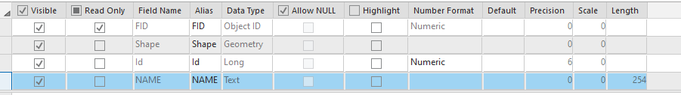

- Exit that window once you have added the fields and select Yes to save your changes. The attribute table will now have your new field. Type in the school name under NAME.
- Continue to add points for all six of the schools. HINT: Desert Vista High School isn’t labeled on the basemap. To confirm that you are placing it in the correct location, try turning on the Imagery basemap to see if you can spot the campus near point six on the georeferenced map.
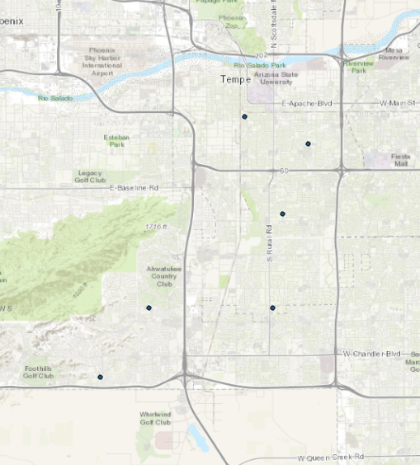

Task: Try digitizing a practice polygon
- Create a new shapefile called Practice, but this time make sure the Geometry Type is set to Polygon rather than point.
- Add a new feature in your practice shapefile by clicking on the layer in the Contents panel and then going to the Edit tab and selecting Create. In the right-hand Create Features panel click on the Create a Polygon tool.
- Start a polygon by clicking to add vertices. Double click or right click and select Finish to stop sketching the polygon.
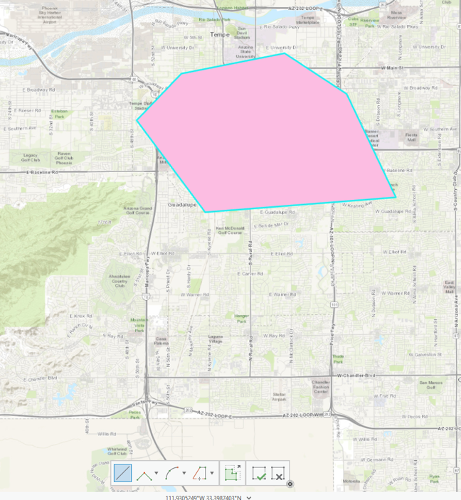

- Try adding an adjacent polygon using the using the Autocomplete Polygon tool next to the Create a Polygon icon. When creating a new polygon that is adjacent to an existing feature, the Autocomplete tool can be selected so that you only have to draw the new part of the feature and the software will ensure that the polygons share a coincident boundary free of gaps or overlaps. To use it, draw a line along where you want the new boundary. Double click to finish.
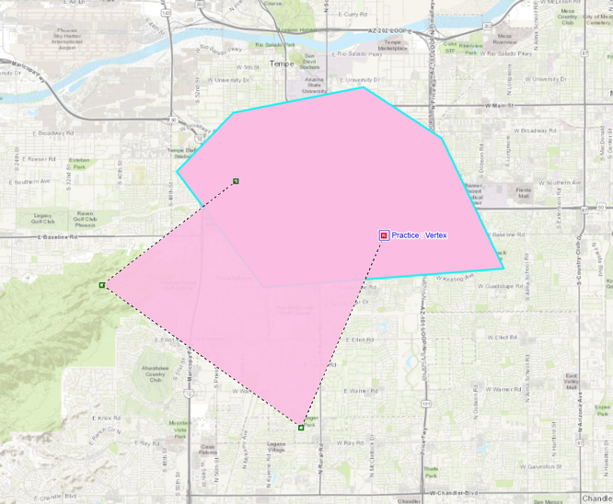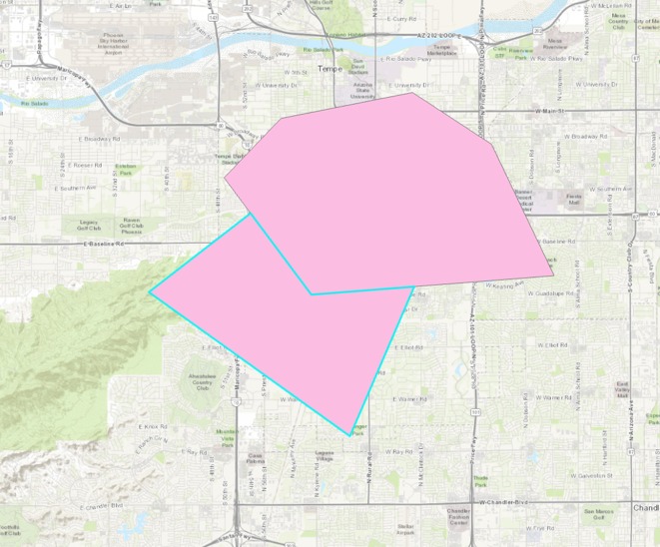

- Feel free to experiment with the tools for sketching polygons until you feel comfortable moving on and starting digitization of the 2019-20 High School AZBs. If you are looking for an extra practice challenge, try tracing the boundaries of a feature on the basemap such as a lake or park.

Digitizing the 2019-20 High School AZBs
Task: Create a new shapefile
- We will create a new shapefile for the 2020 high school AZBs. Within Arc Toolbox, go to Data Management Tools -> Feature Class -> Create Feature Class.
- Under Feature Class Location it will automatically fill the project geodatabase. Instead, change this to be a folder on your computer. This will save your new layer as a shapefile rather than feature class. Call your layer Tempe_HS2020, make sure Geometry Type is set to Polygon and that the coordinate system is the NAD83 Arizona Central projection we selected for the project earlier. Click run in the bottom right corner.
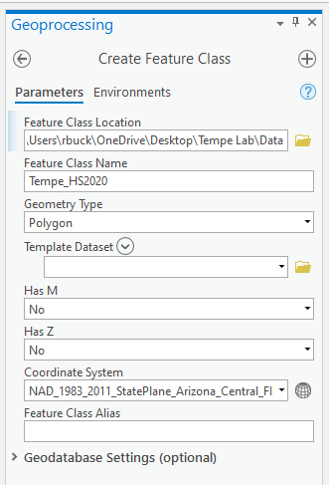
Task: Create features for each high school AZB
- To add a new feature, select your Tempe_HS2020 layer in the Contents panel and then go to the Edit tab and select Create. In the right-hand Create Features panel click on the Create a Polygon tool.
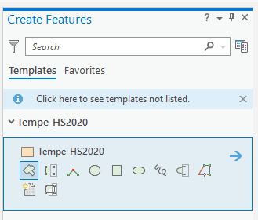
- One at a time, begin tracing features from the georeferenced JPG using the editing tools in ArcGIS Pro. Click to place vertices. Once you have at least three vertices placed, you can right click and select Finish to finish creating the polygon. To edit a completed feature, click Modify in the Edit tab and then select an editing tool. Edit Vertices will be the most useful as it allows you to move, add, and delete vertices. To move a vertex, select it and drag. The same process can be used to move segments. To add a vertex, right click on a segment and select Add Vertex in the dropdown menu. It may be helpful to increase the transparency of your layer in the Appearance tab. You will notice that the warping in the georeferenced image complicates the digitization process. Use the georeferenced JPG as a guide, but also use the basemap to identify where boundaries that follow real-world features such as roads should fall. Below is the finished boundary for McClintock High School:
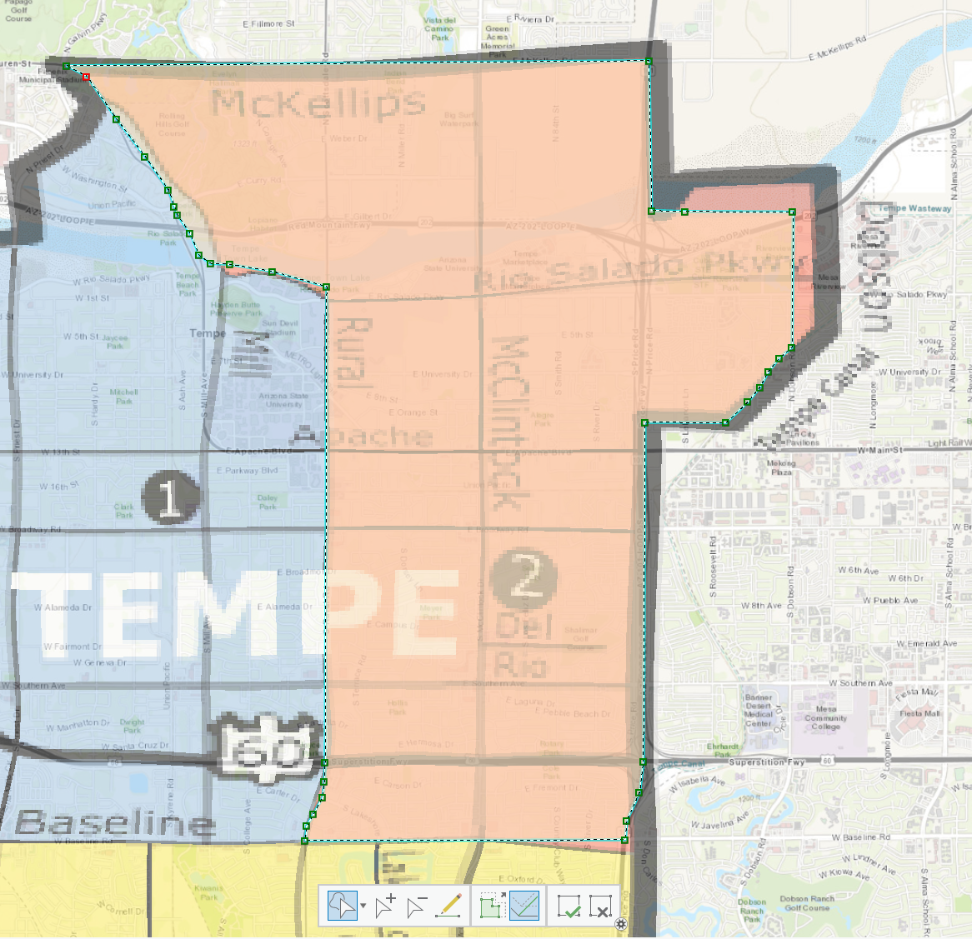
- Make sure to save your edits early and often!
- After saving your edits from your first boundary, open the attribute table and click Add to add a new field. This option will only be available to you if you don’t have any unsaved changes. If it is not available, try saving again. After click Add a new window will pop up and you should create the following new fields: SCHNAME (text), STATE (text), NCESID (text), DISTRICT (text), and LEVEL (long).
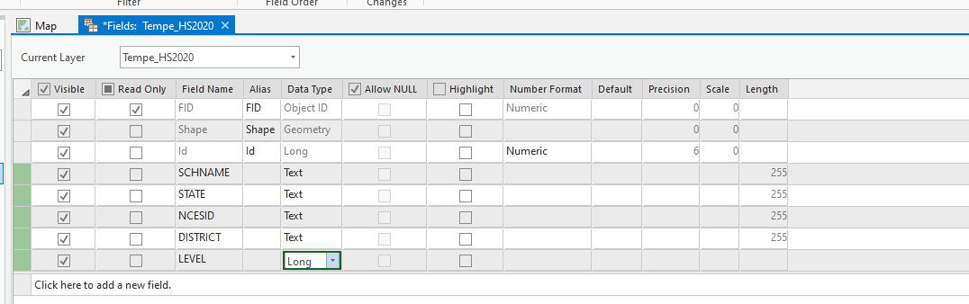
- Exit that window once you have added the fields and select Yes to save your changes. The attribute table will now have your new fields. Ignore STATE, DISTRICT, and LEVEL for now, but type in the school name under SCHNAME. For NCESID, refer to the excel table tempe_schools and select the worksheet HS2020. Refer to the column “School ID – NCES Assigned” to get the correct NCESID for each school. Your attribute table should look something like this:
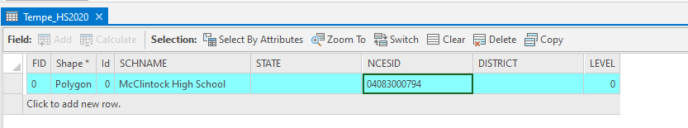
- In the first task of the previous section, you made sure that Snapping was enabled in your project settings. Snapping is an important tool for maintaining data topology as it helps to prevent some of the gaps and overlaps that occur from imprecise vertex placement. ArcGIS Pro allows you to select the kind of snapping you want (point, end, vertex, and edge) as well as the tolerance. The Autocomplete Polygon tool we used earlier is another topology tool that will not only help ensure the quality of your data but will also save you considerable time. The Split tool, which will be used especially in the final section of this lab, allows you to cut polygons by tracing a line through them.
- You will notice that Mountain Pointe and Desert Vista High Schools are both multipart polygons. To digitize this, digitize the two different parts and merge them by selecting both features and selecting the Merge tool. From the panel that pops up, select the feature with the attributes you want to preserve and click Merge in the bottom corner.
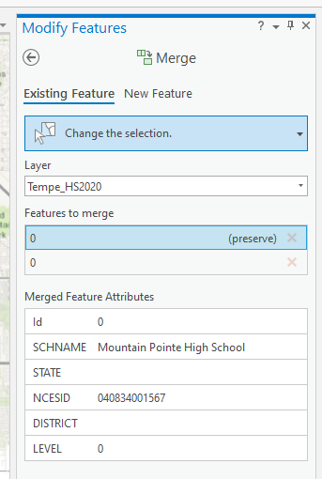
- Once you have digitized all six AZBs, open the attribute table and select all features. Click on the Calculate tool. You will use this tool to fill in the values for the remaining fields. STATE should be ‘AZ’, DISTRICT should be set equal to ‘0408340’, and LEVEL should equal 3.
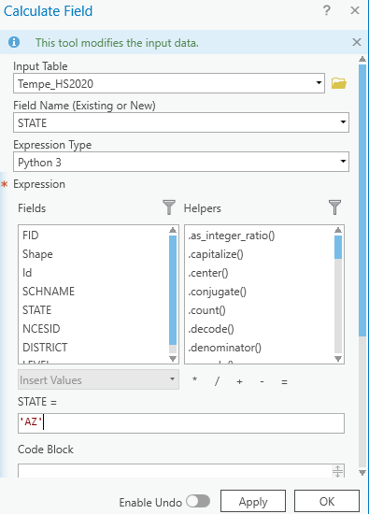
- Your finished product may deviate slightly, but should look something like this:
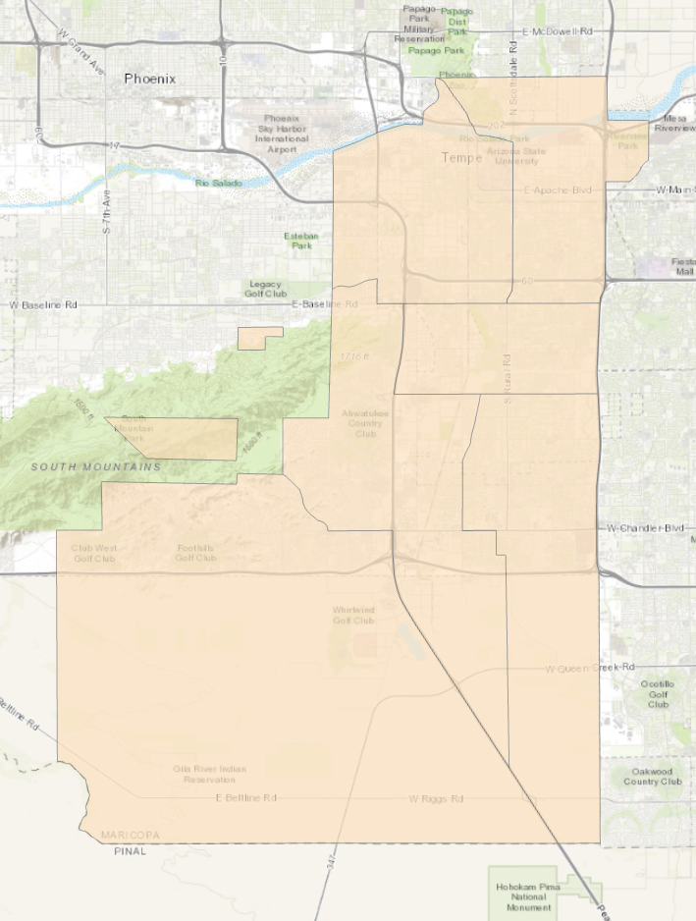

Digitizing the 1999-2000 AZBs
Not all school districts have maps of their AZBs, particularly for historical boundaries. For the 1999-2000 AZBs, all Tempe was able to provide us with is a textual description of the boundaries. Now that you have some familiarity with the digitizing process, you will be editing an existing 2010 AZB shapefile to match the description of the 2000 boundaries in the High_School_1999_2000.pdf document.
Task: Export Tempe_HS2010 to create a new Tempe_HS2000 shapefile
Task: Edit the boundaries of the AZBs in this new Tempe_HS2000 shapefile to follow the descriptions in the High_School_1999_2000.pdf
- HINT: You may have trouble locating some of the roads or canals on the topographic basemap. If that’s the case, try switching to the street or imagery basemaps. If you’re struggling to find a road you can use Google maps to help search for it.
- After you’ve finished editing the boundaries, compare the NCESIDs in the attribute table to the NCESIDs in the HS2000 worksheet of the tempe_schools excel spreadsheet. Correct any incorrect information.

Digitizing the 1989-90 AZBs
Task: Export Tempe_HS2000 to create a new Tempe_HS1990 shapefile
Task: Georeference the HighSchool_1989_90.jpg
Task: Edit the Tempe_HS2000 boundaries to match the boundaries in the georeferenced map for 1990
- HINT: There are only four high schools in the 1989-90 school year. You will have to merge the features for Mountain Pointe and Desert Vista into other features and edit the boundaries. The Split tool may come in useful. It allows you to select a polygon and divide it into two features by drawing a line through it. By using the Split and Merge tools together, you can avoid having to manually move many vertices when editing large areas. The Split tool also ensures that we aren’t creating any gaps or overlaps in our data.
- After you’ve finished editing the boundaries, compare the NCESIDs in the attribute table to the NCESIDs in the HS1990 worksheet of the tempe_schools excel spreadsheet. Correct any incorrect information.

